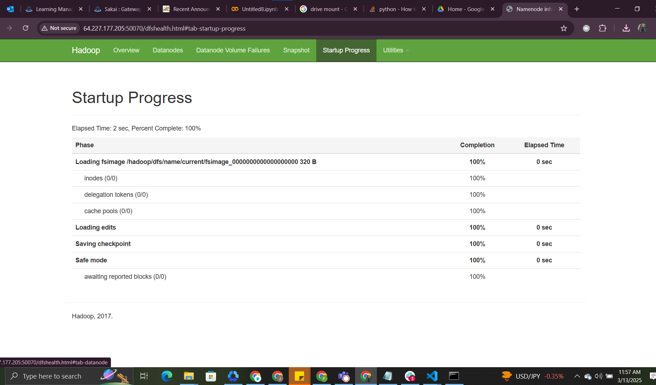  
  
  
<http://64.227.177.205:50070/dfshealth.html#tab-startup-progress>